http://www.rfb.it/bastaveleni/chisiamo.htm

ENOUGH POISON (Basta Veleni)
Hunger Strike to Save the Bees / Campaign Against Neonicotinoid Pesticides

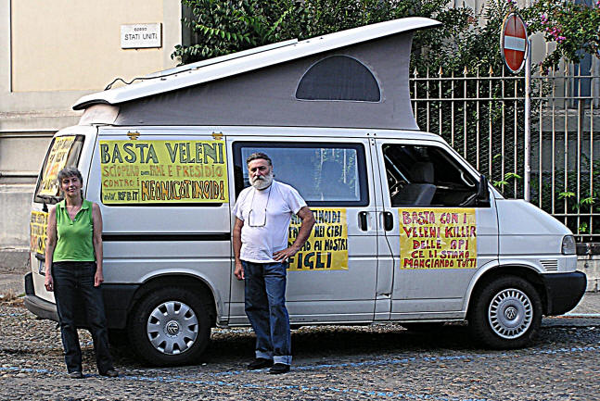

Our names are Marisa Valente and Renato Bologna; a couple of organic farmers who make a living by selling Apitherapy products from our beehives. When we first settled here about 20 years ago this place was an environmental paradise and a haven for bees, rich in wildlife and wildflowers, on the edge of the National Park di Rocchetta Tanaro (AT).
We thought it was the ideal place to create a beekeeping apiary and once we had begun we decided not to use any pesticides, choosing mainly to follow the organic certification Codex. Our landscape is full of blossom all year long, which allows us to harvest the pollen stored by bees in the combs; in addition we collect the ‘bee bread’ or ‘pandapi’, which has always been one of our main products, along with Royal Jelly. We also sell some honey, almost always in the comb. More recently we have specialized in activities such as collection of queen larvae which are used by specialist laboratories to extract valuable neuro-proteins, as medicines for people with immuno-deficiency diseases.
In addition to Apitherapy, Marisa Valente campaigns actively on environmental issues, such as the campaign for a GMO free Europe. She is currently President of the Council of Environmental Organizations for the Province of Asti.
Renato Bologna is a beekeeper and freelance writer, working from time to time for various movements, such as farmers and Altragricoltura Asci.

With this letter in September 7, 2005, we explained for the first time to the various administrators in our region, the critical situation facing us.

"... In 2004 we were no longer able to survive the winter as our bee colonies died; we were at the point of being forced to buy about sixty new colonies, in order to face the coming bee-season of 2005, just to replenish the hives. But in each successive year we found ourselves in an even worse situation: in the period from July to August the collapse of our bee colonies was catastrophic, as high as 80%. We attended many meetings to try and find some new strategy, some ancient strain of bees more resistant to varroa, but nothing worked. "
Come 2011 and nothing has changed. Every year more and more of our bees die, because our business is located in one of the most famous grape-growing areas of Asti, on the edge of the Parco Naturale di Rocchetta Tanaro. The bee-deaths are caused by the toxic pesticide treatments which are "required" for golden vines, among other treatments that have not yet solved the grape-farmers’ problems. If neonicotinoid pesticides are sprayed on the vines, even once, this is deadly for our bees. All of this has been scientifically confirmed: in fact these insecticides were also used as ‘systemics’ for seed treatment of corn (maize), which killed millions of bees, and, as a result their use on maize in Italy has been banned for some years.
To date more than 50 different neonicotinoid pesticides were licensed by the Italian Ministry of Health, for use on the main fruit and vegetable crops: tomatoes, eggplant, peppers, cucumber, squash, melon, watermelon, cabbage, kohlrabi, artichokes, parsley, basil, rosemary, chervil, chives, lettuces and other salads, bean, beans, peas, leek, onion, artichoke, strawberry , potato, wheat, barley, alfalfa, tobacco, olive, apple, pear, peach, plum, cherry, almond, apricot, orange, tangerine, mandarin, lemon, grapefruit, grapes. Neonicotinoids are also used on flowers and other uses against moths, flies and fleas.

Nobody cares that these ‘crop protection products’ are deadly poisonous to bees and insects, even at sub-lethal doses . Major scientific studies from France, Germany, Switzerland and Italy have already tested and confirmed the toxicity levels for bees at both acute and chronic, sub-lethal doses.
Bees make a crucial contribution to the pollination of over 225,000 plant species, including 70% of those used in agriculture, and 90% of our fruit and vegetables.
The mass-death of honeybees doesn’t simply affect beekeepers; it is an alarm signal for unimaginable environmental damage, as revealed by the Dutch toxicologist Henk Tennekes in his latest work: "The systemic insecticides: A Disaster in the Making"
For our small company, the financial consequences have been huge: we produce Apitherapy products: royal jelly, queen embryos, bee-bread, pollen, comb-honey. Chemical analysis conducted by ASL and a private laboratory confirmed that the collapse of our bee-colonies and the loss of self-defense capabilities of the remaining bees, was caused by the neonicotinoids. In addition, we discovered that the: pollen, bee-bread and Royal Jelly of our hives, were contaminated with these insecticides (thiamethoxam).
This is totally unacceptable for us; we cannot simply ignore the problem and remain silent in the face of such overwhelming evidence. It is very simple: neonicotinoid pesticides are killing our bees and killing our business.
We realised that if we could not change the rules of use for these insecticides quickly we would be forced to lose the company along with the loss of our home and our capital assets, since we would no longer be able to honour our debts due to falling revenues.
For this reason we decided to campaign in public by supporting the work of Francesco Panella, president of the Italian National Beekeepers Association (UNAAPI), who has been fighting the same problem for years, at regional, national and European level.
We decided we would start a hunger-strike Turin, Regione Piemonte, on July 4, 2011, and fight to the bitter end, unless the authorities give us firm guarantees to withdraw these neonicotinoid insecticides from the market.
For more info please visit our website at www.rfb.it / bastaveleni where we publish daily "live" updates.

Our Appeal
The license to use neonicotinoid insecticides should be permanently revoked, for all uses, not just for the growing of maize!
Neonicotinoids should never be used at any time, in any form, because these highly toxic insecticides are systemic; they are distributed throughout the plant in sap, leaves, pollen, nectar and grain or fruit. Bees come into contact with lethal or sub-lethal doses of the poison as they collect and eat nectar and pollen. But they may also drink the early morning exudations of plant-sap (guttation droplets) sometimes called ‘honeydew’. We must force the withdrawal of all the neonicotinoids which are already registered, and we must prevent new registrations.
We asked the President of Regione Piemonte, the lawyer Roberto Cota, to enforce the law to safeguard our local cultural heritage, such as beekeeping, by banning the use of these systemic insecticides. We appealed to him to adopt the Precautionary Principle, to protect the environment, our cultural heritage, our butterflies, bees and other insect pollinators as well as human health
We decided we must sacrifice our jobs for this hunger-strike because we have no further options:

- We cannot just watch our bees dying in spasms from poison intoxication.
- We cannot sit and do nothing while this deadly poison flows into the hive, with the pollen and nectar to contaminate the hive products.

For some years we have been unable to meet our customer-orders and the business was at risk of closing. Our only option was to stop working in the place which had once been a paradise for bees, - to sell our property and emigrate to an environment where the bees can survive and work for us.

All this seems terribly unjust; we cannot understand how the survival of bees and bee-farmers can be less important than the financial interests of those who produce these pesticides.

- Why should the profits of pesticide manufacturers triumph over the interests of those who protect wildlife and the environment?

- Why should pesticides be more important than the health of people who live in this area?

We decided that ‘enough is enough’ and grasped at this last straw.
- We appeal to all of you who love Nature, to all those who want to save the bees.
- We appeal to everyone who wants to change this system of chemical farming, based on short-term profit, without any thought for the damage caused to the environment, wildlife and human health.
- We appeal to all of you who want farms to produce healthy foods instead of poisonous wastes.

Please help us to fight and win this battle.
On our website at www.rfb.it / bastaveleni you will find more information.
Please take action yourself, start a campaign, print flyers, spread the story via the Internet. Your actions can help us realise this dream, and sometimes dreams do come true!
We also need financial donations to support us while we are doing this work.
You can use a simple bulletin Postal Account. Please send a donation to the account
Number 1000095776 payable to Friends of the Farm.
Thank you in advance, to all who respond to our appeal.
Marisa Valente: 3343403464
Renato Bologna: 3208310702
Email: fattoria@atlink.it
http://www.rfb.it/bastaveleni/chisiamo.htm

